**ANALOG READ SERIAL**

This example shows you how to read analog input from the physical world using a potentiometer. A **potentiometer** is a simple mechanical device that provides a varying amount of resistance when its shaft is turned. By passing voltage through a potentiometer and into an analog input on your Chipkit UNO32, it is possible to measure the amount of resistance produced by a potentiometer (or *pot* for short) as an analog value. In this example you will monitor the state of your potentiometer after establishing serial communication between your Chipkit UNO32 and your computer.

**Hardware Required:**

* Chipkit UNO32 Board
* 10-kilohm Potentiometer

**Circuit:**

Connect the three wires from the potentiometer to your Chipkit UNO32 board. The first goes to ground from one of the outer pins of the potentiometer. The second goes from 5 volts to the other outer pin of the potentiometer. The third goes from analog input 2 to the middle pin of the potentiometer.

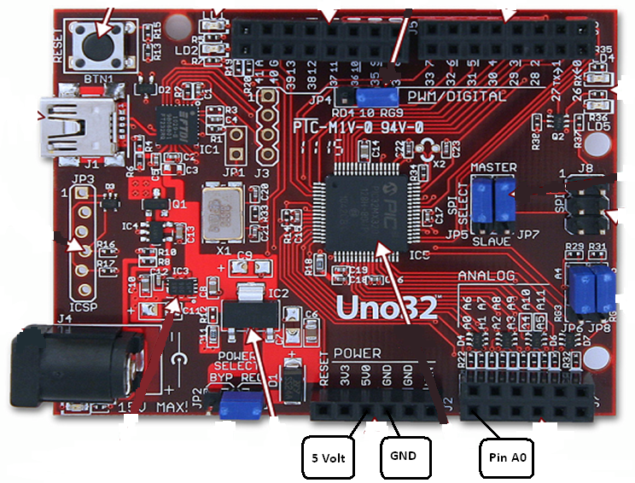

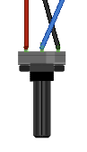

By turning the shaft of the potentiometer, you change the amount of resistance on either side of the wiper which is connected to the center pin of the potentiometer. This changes the voltage at the center pin. When the resistance between the center and the side connected to 5 volts is close to zero (and the resistance on the other side is close to 10k ohms), the voltage at the center pin nears 5 volts. When the resistances are reversed, the voltage at the center pin nears 0 volts, or ground. This voltage is the **analog voltage** that you're reading as an input.

The Chipkit UNO32 has a circuit inside called an **analog-to-digital converter** that reads this changing voltage and converts it to a number between 0 and 1023. When the shaft is turned all the way in one direction, there are 0 volts going to the pin, and the input value is 0. When the shaft is turned all the way in the opposite direction, there are 5 volts going to the pin and the input value is 1023. In between, [analogRead](http://arduino.cc/en/Reference/AnalogRead)() returns a number between 0 and 1023 that is proportional to the amount of voltage being applied to the pin.

**Code:**

In the program below, the only thing that you do will in the setup function is to begin serial communications, at 9600 bits of data per second, between your Chipkit UNO32 and your computer with the command:

Serial.begin(9600);

Next, in the main loop of your code, you need to establish a variable to store the resistance value (which will be between 0 and 1023, perfect for an [int datatype](http://arduino.cc/en/Reference/Int)) coming in from your potentiometer:

int sensorValue = analogRead(A0);

Finally, you need to print this information to your serial window as a decimal (DEC) value. You can do this with the command [Serial.println](http://arduino.cc/en/Serial/Println)() in your last line of code:

Serial.println(sensorValue, DEC)

Now, when you open your Serial Monitor in the Chipkit UNO32 development environment (by clicking the button directly to the right of the "Upload" button in the header of the program), you should see a steady stream of numbers ranging from 0-1023, correlating to the position of the pot. As you turn your potentiometer, these numbers will respond almost instantly.

*/*  
  AnalogReadSerial  
  Reads an analog input on pin 0, prints the result to the serial monitor.  
  Attach the center pin of a potentiometer to pin A0, and the outside pins to +5V and ground.  
   
 This example code is in the public domain.  
 */*  
  
*// the setup routine runs once when you press reset:*  
void **setup**() {  
  *// initialize serial communication at 9600 bits per second:*  
  Serial.begin(9600);  
}  
  
*// the loop routine runs over and over again forever:*  
void **loop**() {  
  *// read the input on analog pin 0:*  
  int sensorValue = analogRead(A0);  
  *// print out the value you read:*  
  Serial.println(sensorValue);  
}